GSK Enrichment Tool

# About

This tool will take as input a list of Vault objects (excel sheet format) and, using a Vault API call, retrieves picklist information. The output is a csv file with object information.

# Pre-Requisites

* The Latest available version of Python, from <https://www.python.org/downloads/>, should be downloaded and installed.
* An Input Excel sheet should be available with the following columns:

|  |  |
| --- | --- |
| **Example Input File** | **Description** |
|  | Objects should be in the order you wish to view the columns in the resulting output.  There should be no empty cells. |
| ***Picklist Naming Convention*** | Add the “**picklist-**“prefix to all the picklists values |

# User Instructions

1. Download the executable from the DMT SharePoint site
2. Double Click on **GSKEnrichmentTool.0.9.exe**
3. These pop ups may appear:

Click Run anyway

1. The **GSK Enrichment Tool** window displays:

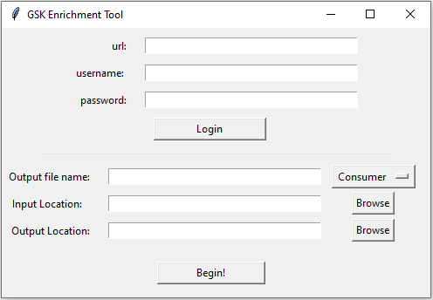

# Using GSK Enrichment Tool

|  |  |
| --- | --- |
| **Login Field Name** | **Details** |
| ***URL*** | The full URL to your Vault you are trying to access.    A URL that begins with the https:// up to and including the .com:  Example: https://allergan-qualitydocs.veevavault.com |
| ***Username*** | Enter Vault username  Example: [migration.account1@allergan.com](mailto:migration.account1@allergan.com) |
| ***Password*** | Your Vault password (case sensitive) |
| ***Login*** | Once Login is successful you should see “***Login Successful***” |
| ***File Name*** | File Name without any extensions e.g. .xls, .csv |
| ***Consumer/***  ***Enterprise***  ***Dropdown*** | Select from options “***Consumer***” or “***Enterprise***” from the dropdown menu button. |
| ***Input Location*** | Select the input file by clicking “***Browse***”  Example: C:/Users/user-name/Documents/Input_File.xlsx  *\*****important***  Excel input file should not have empty cells |
| ***Output Location*** | Select folder that will house the output file by clicking “***Browse***”.  Example: C:/Users/user-name/Documents |
| ***Begin*** | Once clicked you should see the following screen and a green progress bar at the bottom indicating the program is working and processing the request.    Once completed you should see: **Download Complete** at the bottom of the screen. |

# Troubleshooting

1. **Issue**: Tool does not complete after clicking Begin!
   * **Solution**: Make sure the latest version of Python is downloaded
2. **Issue:** Wrong username or password
   * Should show:

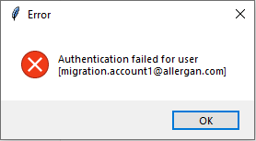

* + **Solution**: double check username or password

1. **Issue:** Incorrect URL
   * Should show:

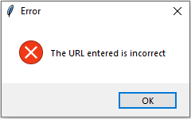

* + **Solution**: double check URL is correct

1. **Issue:** Object does not exist
   * Should show:

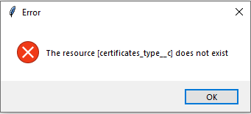

* + **Solution**: Fix object in spread sheet